Australian Optical Society
Propagation in straight and bent photonic crystal waveguides
L. C. Botten¹, A. A. Asatryan^{1,2}, T. N. Langtry¹, R. C. McPhedran² and C. M. de Sterke²
¹Department of Mathematical Sciences, University of Technology, Sydney, Broadway, NSW 2007, Australia
²School of Physics, University of Sydney, NSW 2006, Australia
An essential component in the design and fabrication of large scale integrated optical circuits is the photonic crystal (PC) waveguide, a device which can channel light, without loss, around tight bends using band gap effects. Studies of such guides have been almost exclusively computational yielding no analytic insight into the propagation mechanism. We initially consider 2D waveguides comprising a channel defect modelled by a resonant cavity sandwiched between two semi infinite PCs, each characterised by a reflection scattering matrix that is represented in the basis of Bloch modes basis for the perfect PC. Figure 1 shows dispersion curves for a family of waveguides of normalised width /d.
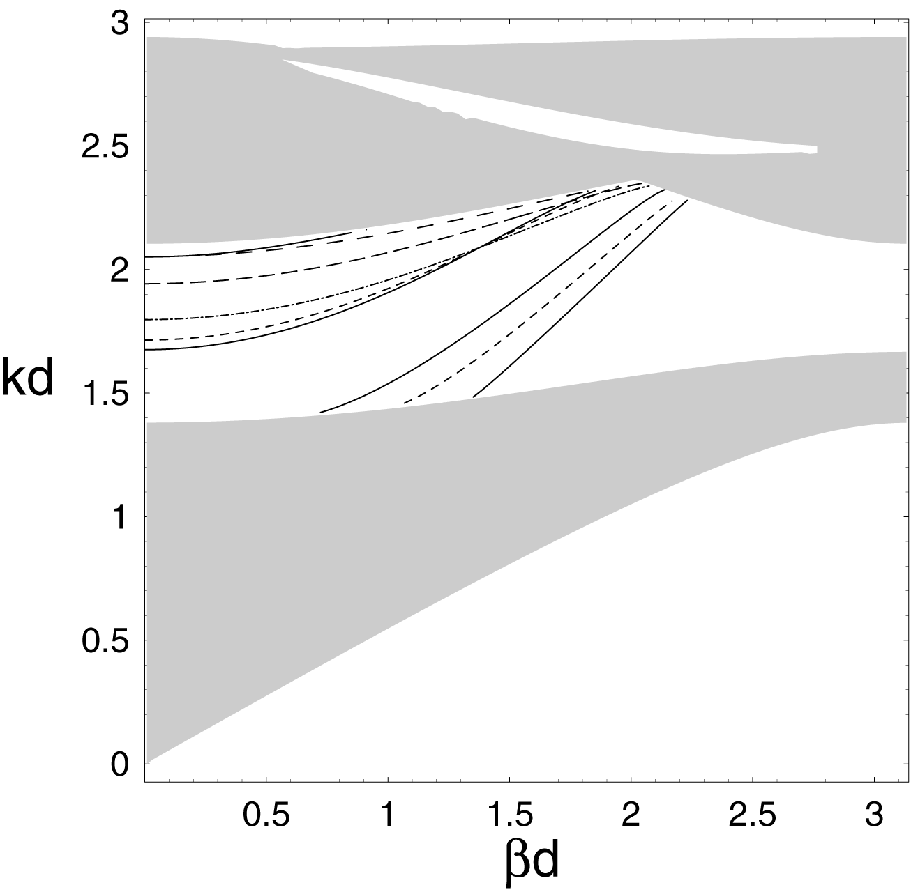
Fig. 1 Dispersion diagrams for a straight waveguide showing normalised free-space wavenumber vs normalised propagation constant for guides (composed of dielectric rods of index 3.0 and normalised radius 0.3) of different thickness h: Solid curve h/d=5; short dashed h/d=3; dash-dotted h/d=1; long-dashed h/d=0.7; medium dashed h/d=0.4. Shaded regions show bands of the PC where a line defect cannot have modes.
This model produces excellent agreement in the dispersion properties and location of Fabry-Perot resonances (in the transmission spectrum) with the results for an actual finite structure. Field and energy properties, however, are best modelled using a supercell method which treats the structure as periodic array of channels. In this way, the cut-off frequency occurs as a bandgap of the supercell structure. We accurately model reflection and transmission of waves in finite guides, and by joining two supercell structures having slanted channels, we go on to characterise the reflection and transmission properties of a waveguide bend in a Bloch basis.

