Cavity Design of A Yb:YAl₃(BO₃)₄ Kerr Lens Mode-locked Laser

Yanrong SONG, Bronwen TAYLOR, Peter DEKKER, Judith DAWES, Jim PIPER

(Centre for Lasers and Applications, ICS, Macquarie University, NSW, 2109, Australia)
Tel:+61-2-98508923, Fax: +61-2-98508983
E-mail: yrsong@ics.mq.edu.au,

Recently Ytterbium (Yb³⁺)-doped crystals have been widely used in different solid-stated lasers because of the crystal’s low thermal-load and the convenience of diode pumping. Compared with Nd³⁺-doped lasers, Yb³⁺-doped crystals exhibit broadband fluorescence, which allows tunability and/or ultra-short pulse generation at wavelengths around 1040 nm. The shortest pulse achieved in a mode-locked Yb³⁺-doped crystalline laser is 71-fs[1], which was generated with Yb:KY(WO₄)₂ as the laser gain medium. So far, no results have been reported for Kerr lens mode-locked (KLM) Yb:YAl₃(BO₃)₄ (Yb:YAB) laser.
In this study, we designed a Yb: YAB KLM laser cavity pumped by a diode laser and modeled it using ABCD-matrix formalism. We calculated the spot size at different positions, the stability of the cavity versus the cavity length, the focal length of the Kerr lens generated in an intracavity SF 57 glass plate and relative beam-size sensitivity $δ$($δ=(1/ω){dω}/{\text{dp}}$,$ω$is the beam radius) to the normalized pulse power p (Fig.2). This figure shows that the mode-locking effect is sensitive to the position of the nonlinear Kerr media. Using this theoretical analysis, a suitable cavity was designed (Fig.1). The performance of the cavity is being tested experimentally.

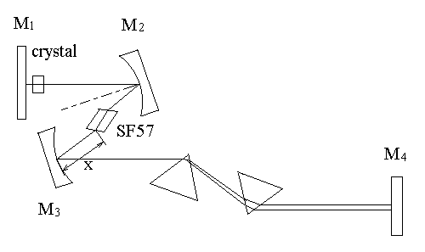
Fig. 1 Experimental set up Fig. 2 Beam-size sensitivity to the normalized pulse
power vs. the position of the Kerr medium

[1]. H. Liu, J. Nees, G. Mourou. Diode-pumped Kerr-lens mode-locked Yb:KY(WO₄)₂ laser. Optics letters. 26, 1723 (2001).

