Optimization of Chirped Pulse Amplification Systems using Martinez Stretcher

Yanrong SONG, Zhigang ZHANG, and Qingyue WANG
School of Precision Instrument and Optoelectronics Engineering,
University of Tianjin, Tianjin 300072, P. R. China
Tel: +86-22-27402450, Fax: +86-22-27404204
Email: yrsong@ics.mq.edu.au

In Chirped Pulse Amplification (CPA) Systems, we use stretcher to expend the pulse in domain to avoid the intracavity intensity too high to damage the elements and the nonlinear effects. After amplification, the pulses are recompressed by the compressor. The Martinez stretcher^{[1]} is commonly used in this system, however, it has not been optimized due to a lack of appropriate formalism. Numerical ray-tracing has been used in the past. Unfortunately, the Treacy formula^{[2]} with an opposite sign was used to predict the performance of the Martinez stretcher as well as the Offner stretcher. The fatal problem of using Treacy formula is a real stretcher has significant mirror aberration, which becomes phase dispersion.
We derived an analytic model for the phase of Martinez stretcher. With which, we analyzed the phase dispersion of a CPA system including a multipass amplifier or a regenerative amplifier. The model revealed new insights. First, the system phase is sensitive to the grating position in the stretcher and this can be used to compensate the high order phase. Second, for a regenerative amplifier, adjusting any parameters does not result in a broader bandwidth greater than 100 nm. Third, in a multipass amplifier, a very broad phase window (~200-nm bandwidth, Fig.2) can be achieved for supporting further short pulse amplification. Experimental confirmation is underway.

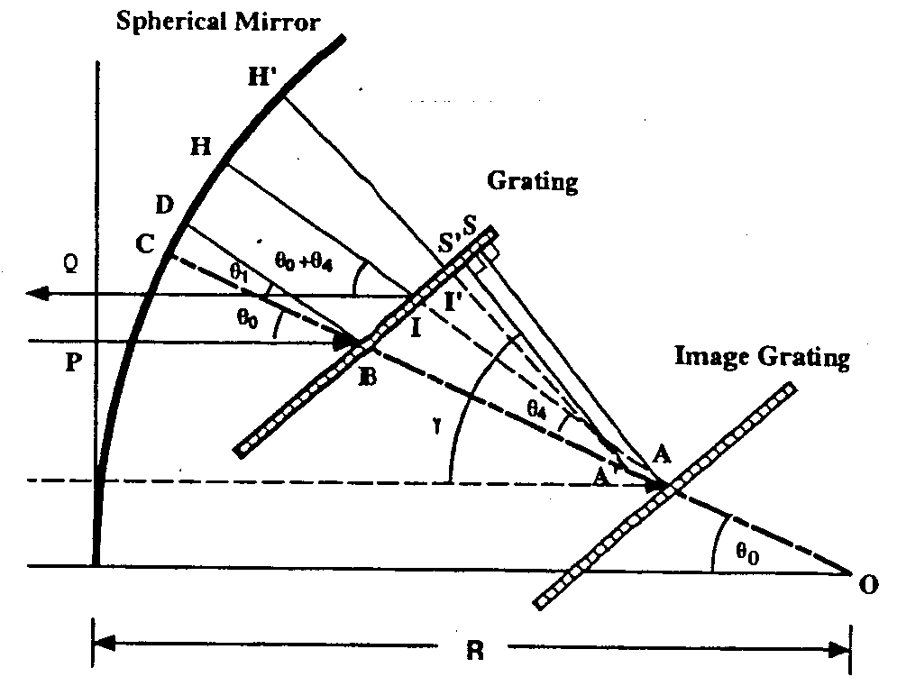

Fig.2 The optimized group delay of a multipass amplifier,
Fig. 1 Structure of the Martinez Stretcher. (D, D_{C:} the grating groove densities in stretcher and
compressor respectively, S_{1:} grating position.)

[1]. O. E. Martinez, IEEE Journal of Quantum Electronics QE-23, 59-64 (1987).
[2]. Z. Zhang, T. Yagi and T. Arisawa, Appl. Opt. 36, 3393-3399 (1997).

