Single Rail Quantum Logic in Optics

A.LUND and T.C.RALPH
Centre for Quantum Computation, University of Queensland,
St Lucia, QLD 4072 Australia
Ph: 07 3365 3412, Fax: 07 3365 1242, email: lund@physics.uq.edu.au

The standard method for encoding qubits in optics is to use the polarisation degrees of freedom of single photons. This is sometimes referred to as dual rail logic because it uses the occupation, or not, of two orthogonal polarisation modes as the qubit. This type of encoding is easy to manipulate and is very forgiving of imperfections in the source and detectors. However there is considerable fundamental interest in alternate encoding strategies, some of which may have practical advantages in the long term. In this presentation we investigate one such strategy, single rail logic. Here the qubit is encoded in the occupation, or not, of a single optical mode. That is the vacuum state, |0> represents the logical zero, whilst the single photon state, |1>, represents the logical one. We construct a universal set of non-deterministic quantum gates, which can be implemented using only linear optics and detection. We investigate some simple experimental arrangements designed to test the performance of the gates and conclude that demonstrations using state of the art technology are possible.

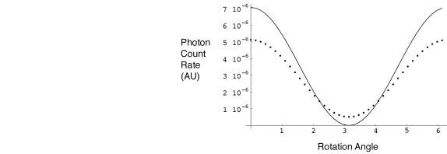
Figure: Rotation of zero/one photon
superposition using non-deterministic
gates. Solid line for 100% efficient
detectors, dotted line 90% efficient.

