Simulations based on the Geant4 toolkit [Agostinelli, Mendenhall] with various divergence angles and with the mask at various angles did not show a configuration by which the implanted particle size could be less than that of the mask pores. The simulation used 14keV Phosphorus-31 particles through 80nm x 15μm pores in aluminium oxide.
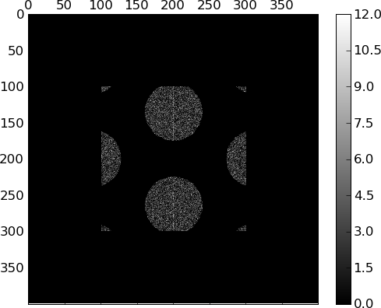
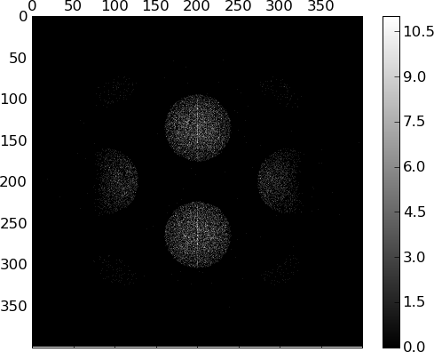

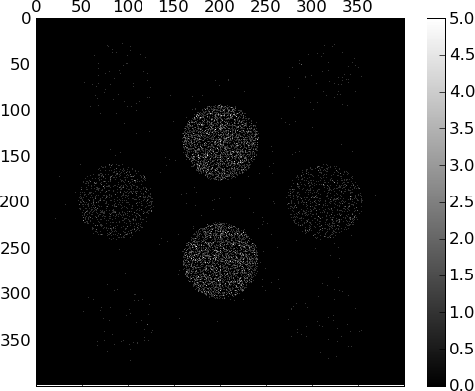
Figure 1:
Divergent implantation beam, for beam divergence of 0, 0.1 and 0.3 degrees. Units are in nm and counts.

With a convergent beam, the implanted particle groups could be smaller than the mask pores, but this also resulted in the implanted particle groups being closer together (Figure 2).
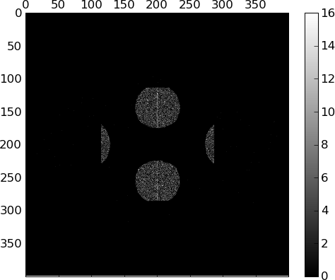

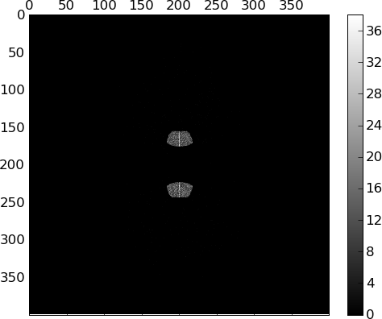

Figure 2:
Convergent implantation beam, for beam convergence of 0, 0.05 and 0.2 degrees.

No simulation parameters could be found that increased the
spacing between implanted particle groups while simultaneously
making them smaller.

References

Agostinelli, S. et. al. GEANT4-a simulation toolkit. NIMR A 506, 250–303 (2003).

Mendenhall, M. & Weller, R. An algorithm for computing screened coulomb scattering in GEANT4. NIMR B 227, 420–430 (2005).

