LEATHER MOTORBIKE JACKET

LVL Bikers Club
(imported)
Size 52
(euro size)
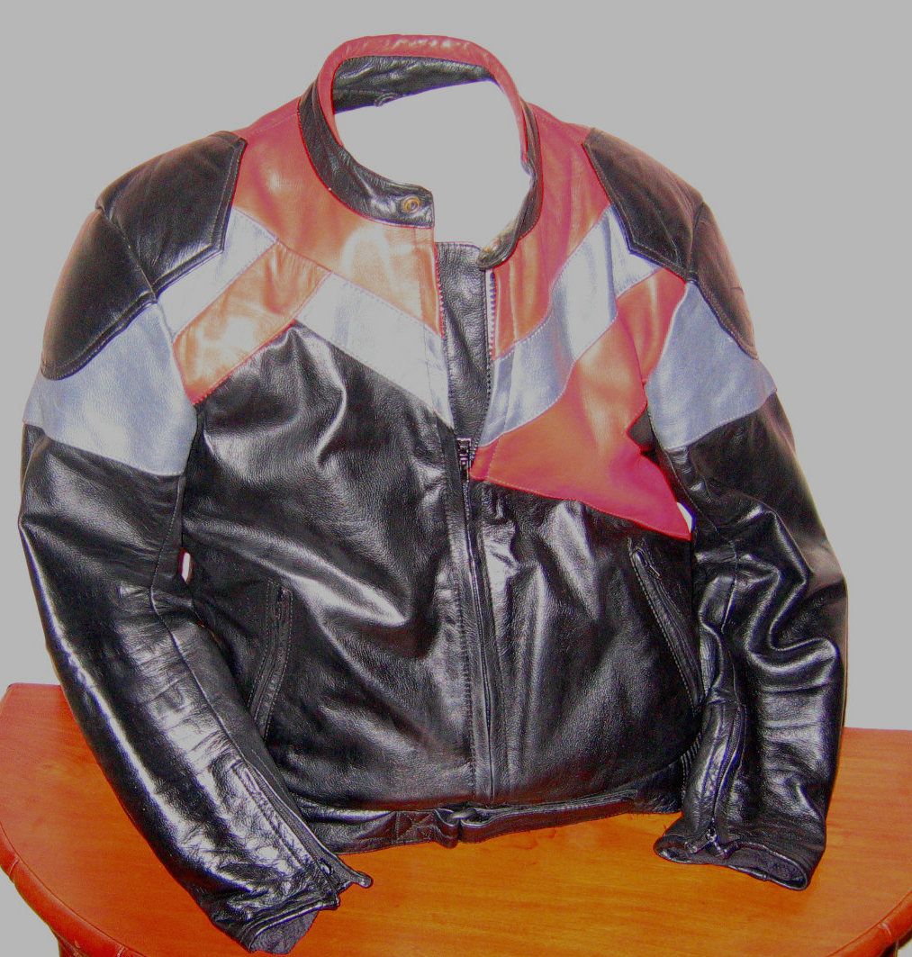

Black with red and grey trim.
Safety inserts in back and elbows
For serious rider

$250
Phone 9859 9725

LEATHER MOTORBIKE JACKET

Diamond Leather
(imported)
Size 42 inch

Black, Brando style.
Waist length

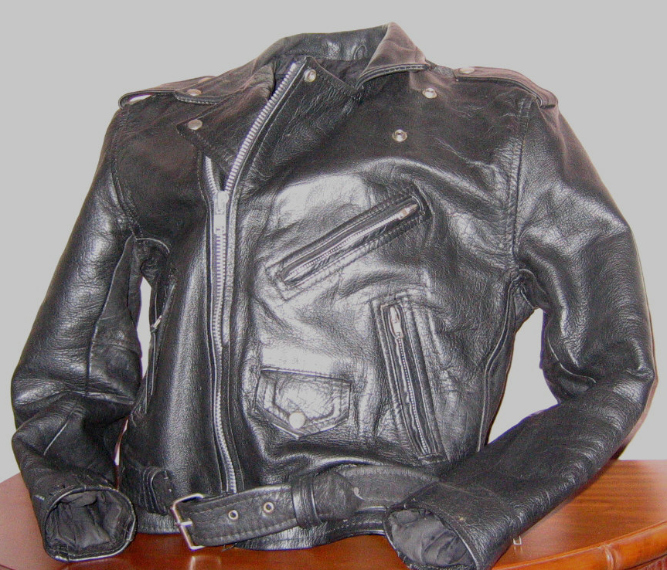

$150
Phone 9859 9725
LEATHER MOTORBIKE JACKET

Made by Stagg
Police style
Size 44 inch

Colour Police blue
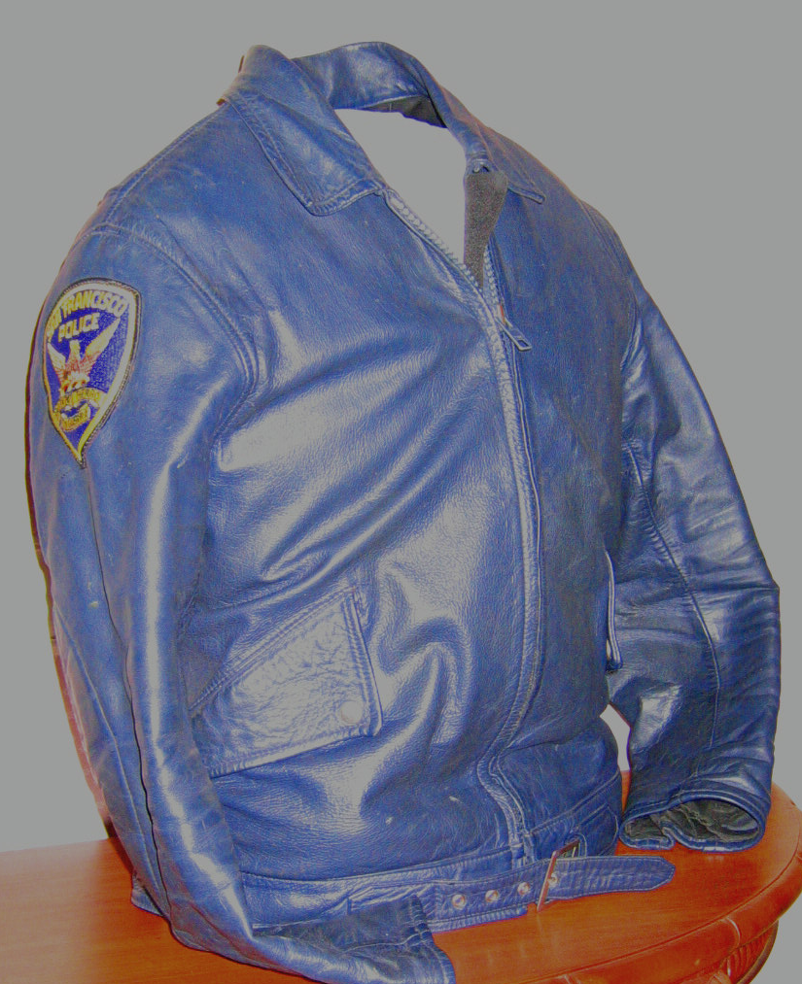
$150

Matching Walden Miller leather pants size 5
$130
Phone 9859 9725

LEATHER MOTORBIKE PANTS

BLACK ROSE

Size L

Black
Fully lined
Excellent condition

$250

Phone 9859 9725
LEATHER RIDING PANTS

Walden Martin

Size 6

Black
As new condition

$160

Phone 9859 9725
MOTORBIKE HELMET

LAZER
Size 57/58

Red, black silver white

$50

Phone 9859 9725
MOTORBIKE BOOTS

Size 8

Rossi

Spider

$40

Phone 9859 9725
LEATHER RIDING PANTS

Off-road
Size 32 inch waist
Black
With Suzuki stripes
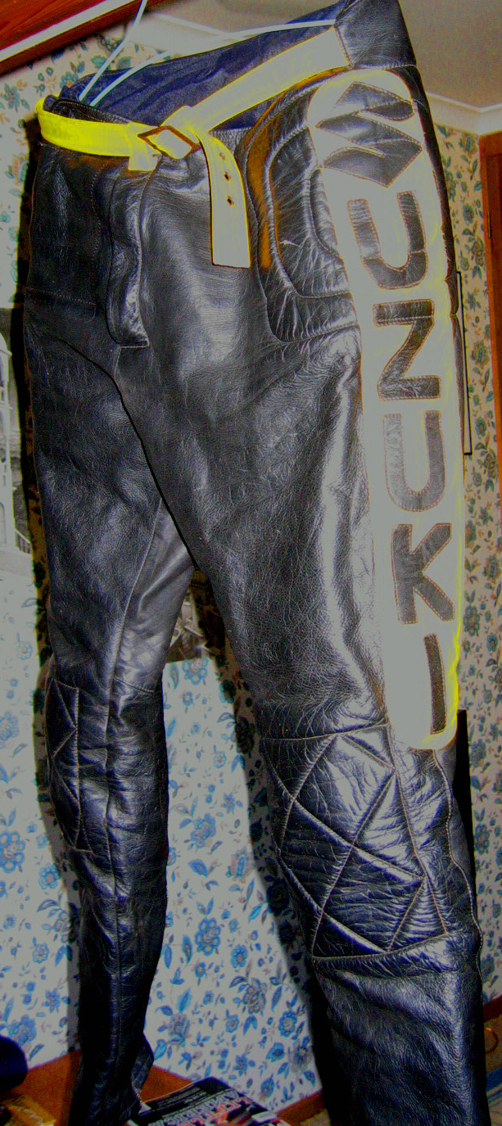
$75

Phone 9859 9725

